

Setting up User Roles
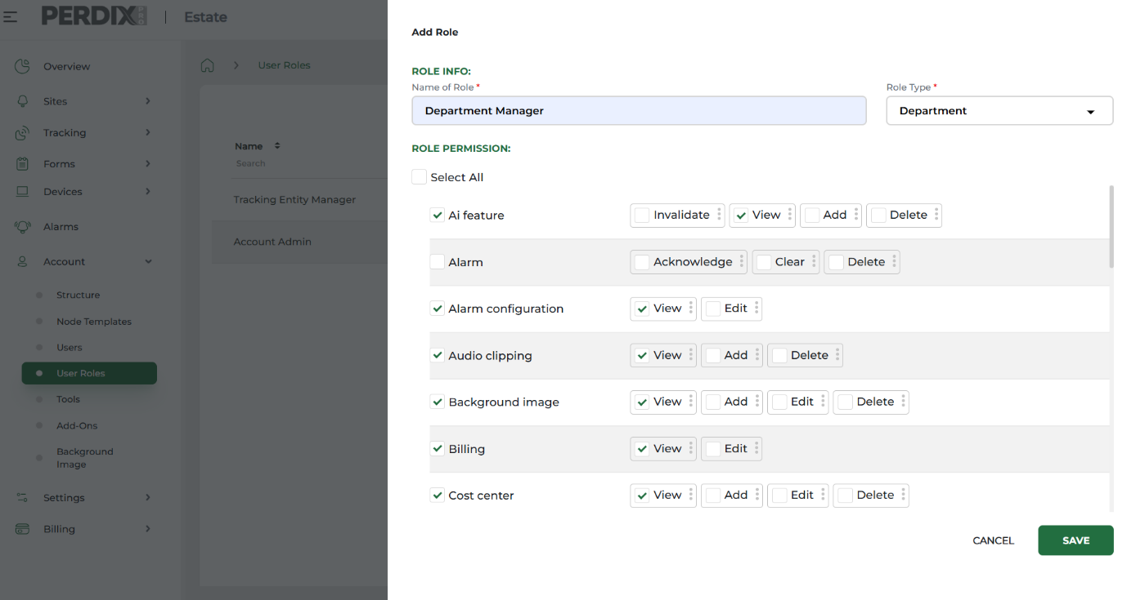
The PERDIXPro platform allows you to add Users and assign to them a specific and uniquely created User Role.
This User Role allocation to an individual User determines the type and level of access each User has to your account structure and the various functionality across the platform.
You can create any User Role required to suit your project, organisation or activity requirements.
To create a User Role navigate to Account > User Roles > Add User Role
Name the new User Role and importantly allocate it a Role Type (see above). This Role Type determines which level of the account structure hierarchy (and below nodes) the User Role has access to.
Account Admins have access to the entire account at System level, but account structure access can be restricted where needed by giving Users certain User Roles for particular sections of the account structure.
Once a User Role has been named and given a Role Type, you can then apply Role Permissions to the User Role to dictate access to various system functionality (see above).
Setting these permissions correctly is key to allowing each User to access what they need across the system to carry out their role i.e. do they need access to billing, do they need to view sites, do they need to access and publish forms etc.

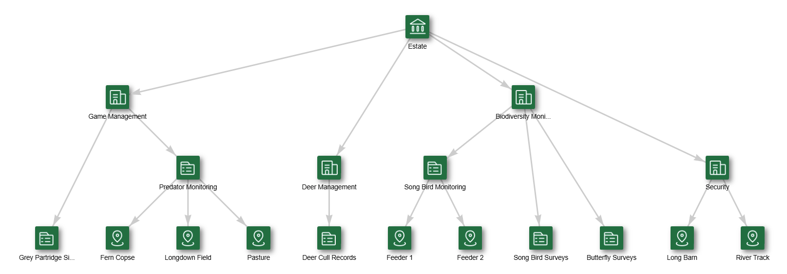
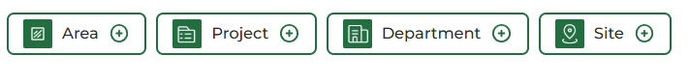
To then give Department managers access to a single or different Departments, navigate to Users > the individual User > Edit button, and select the Role as Department Manager and assign in Entity, the relating Department of the structure they need access to (see Adding Users for more information).

Example User Role allocation – Department Manager
An account structure hierarchy can have green square nodes representing Areas, Projects, Departments or Sites etc - these nodes can be created to suit your own situation (see Setting up your account structure).
A ‘Department Manager’ User Role that has been given a Role Type at Department level can be given access to any green Department nodes (shown circled below) and therefore, the relating nodes below.

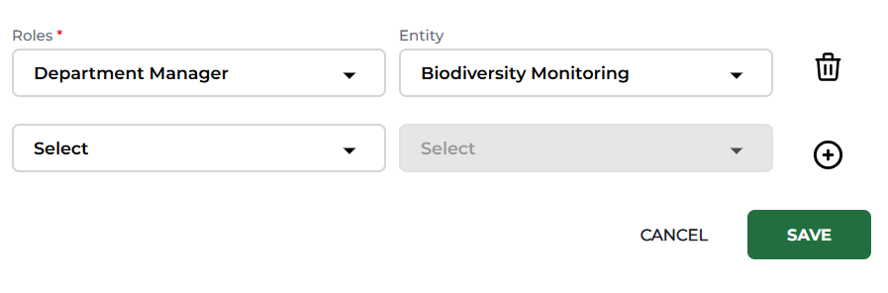

Once a Department Manager has been given access to the Departments(s) they are managing, and permissions are correct, they will only have access via their User log in to their designated area of the structure and its installed devices and associated forms.

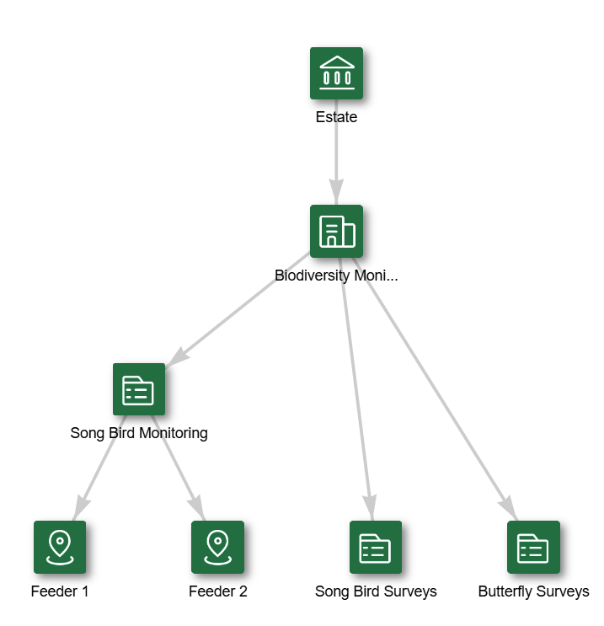

Above shows the view of the restricted account structure when logged in as a User with a User Role of a Department Manager, who has been given access to the Biodiversity Monitoring Department node.

December 2025

