

Adding Users
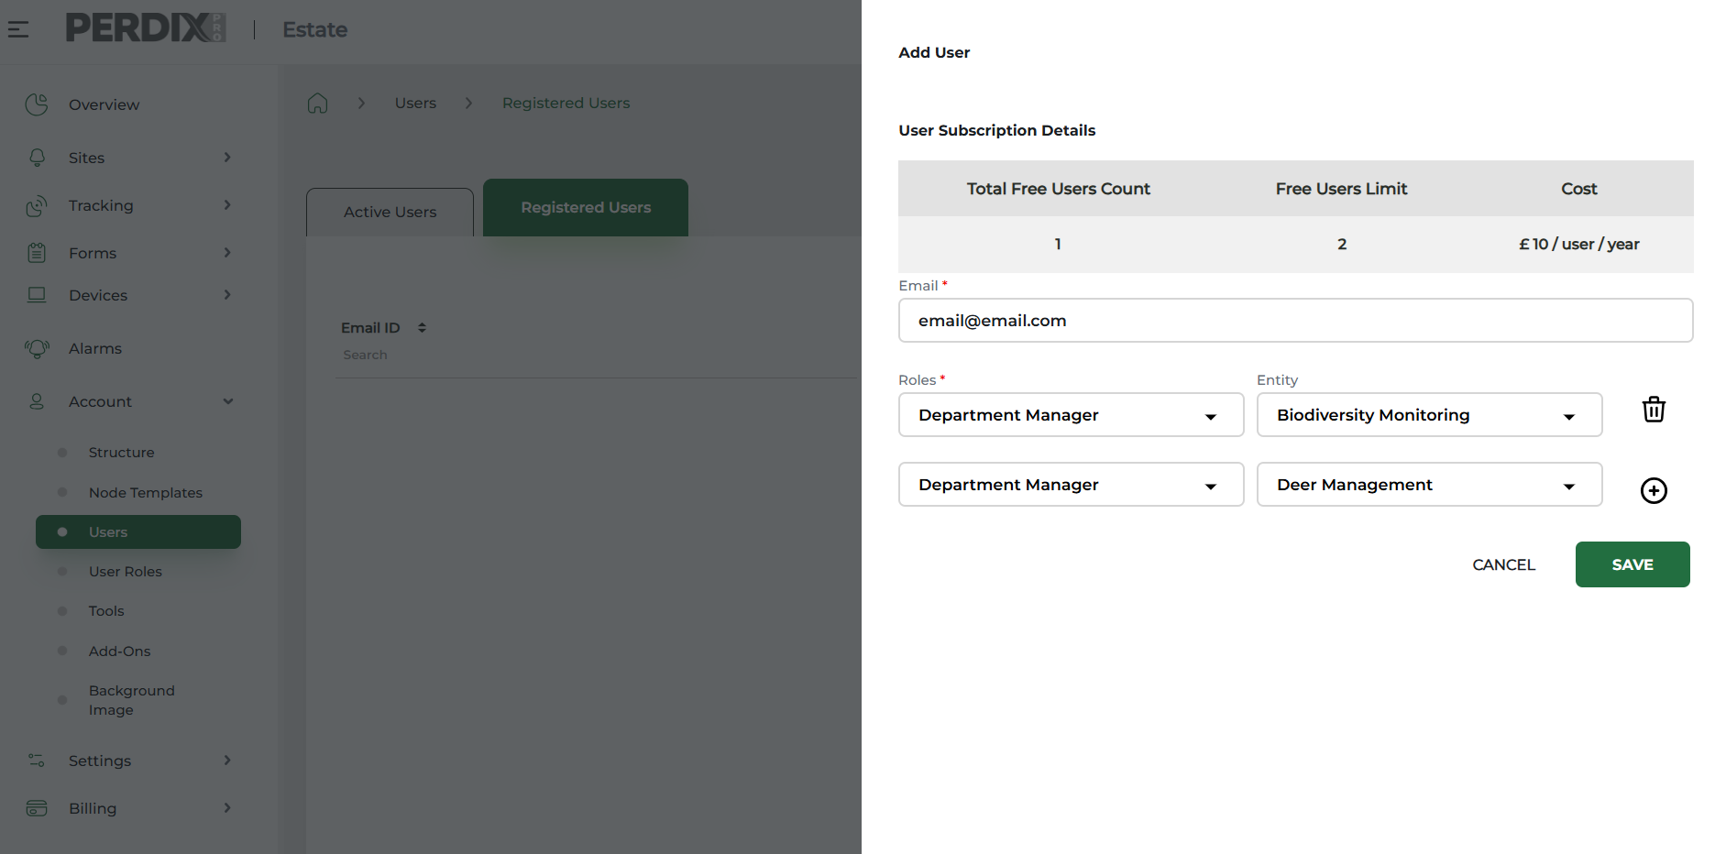
When this information has been saved, the invited User will receive an email from admin@perdixdigital.com with a link to follow to activate their individual access to the account (this email can enter into a spam folder, so please advise of this).
Until the invited User activates their account, their invitation will be ‘pending’ in Registered Users. When the invited User activates their account they will then be listed in ‘Active Users’.
Once the User activates their account access they can log in to the desktop platform of the account, and use the same log in details to log in to the associated PERDIXPro App and PERDIXPro Fieldbook App.

The PERDIXPro platform allows for Users to be added to the account by account admins and existing Users who have this permission.
To invite a User to the platform navigate to Account > Users > Registered Users > Add User.
Here, enter the new User’s email address, assign them a User Role and a level(s) of the structure they are to access via the Entity drop down box.



Troubleshooting
If a User cannot find their access invitation email, this can be re-sent to them by account admins. Navigate to Account > Users > Registered Users and under Actions click the re-send button.
If an account User forgets their password, they can reset their password by clicking ‘Can’t log in’ on the log in page. Alternatively, an account admin can reset the password for the User by navigating to Account > Users > Active Users and under Actions click the reset password button.

December 2025

