

Setting Alarms and Notifications
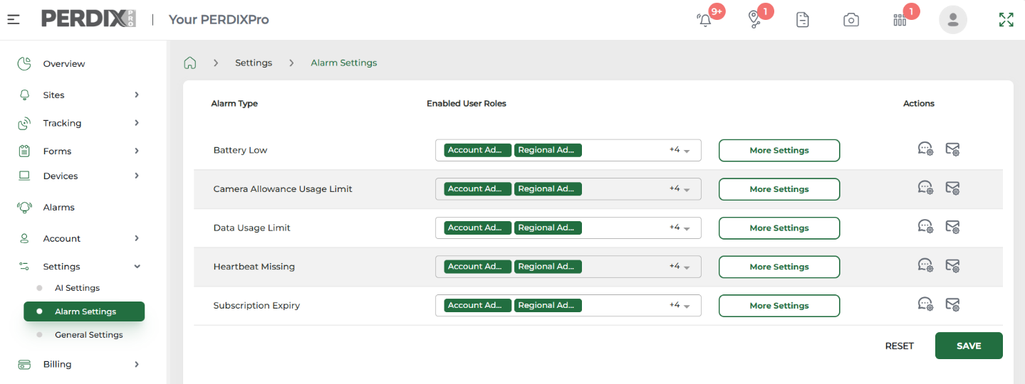
Device Activity Alerts and Notifications
Alerts for device activity (i.e. images received, trap activations, tracking geofence breaches) are generated automatically at the top right hand corner of the PERDIXPro platform and App.

Users need to enable their own alert notifications within their own account for their individual Sites. Notifications for these alerts can be enabled in two ways:
- Open the PERDIXPro App, navigate to Sites > your chosen Site > click > choose SMS/Email/Push.
- Log in to the PERDIXPro platform, navigate to Sites > All Sites > your chosen Site > click > choose SMS/Email/Push.

PERDIXPro provides the ability to set alarms for various device activity alerts relating to trail cameras, traps tags and tracking tags. Alarms can also be set for device & system features, as well as animal recognition (AI).

These alerts and alarms can then be set to be sent to the user as notifications, either via SMS, by email or by push notification. See SMS, Email and Push Notifications Guide.

Device & System Alarms and Notifications
Alarms for device and systems features (such as missing device heartbeats, low battery, subscription expiry etc) can be set and enabled, then be switched on by individual users to receive their own notifications.

To set these alarms, navigate to Settings > Alarm Settings. Here you will see the list of device and system alarms available. For the alarm you require, select the Enabled User Role(s) to set who can receive the alarm(s), and then set the alarm threshold within More Settings. Under Actions, you can create your own notification messages.

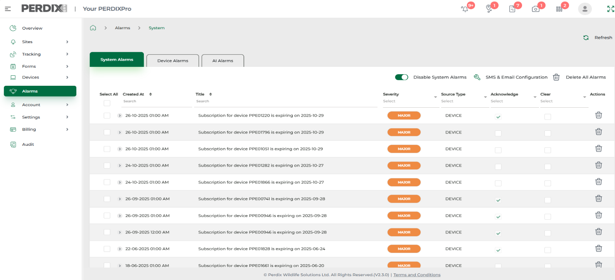
To enable these alarms, navigate to Alarms, and within your chosen alarm tab, toggle on and enable alarms.
The Alarms menu option is where all your device & system alarms (and animal recognition AI alarms if enabled) are listed when received.

Once set and enabled, for individuals to switch on their own alarm notifications, they need to navigate to Alarms > click and choose either SMS or Email (push notifications are not available for device and system alarm notifications, only for activity alerts).

Once alarm settings are correct and the chosen alarms have been enabled, the individual users who are to be notified of an alarm will need to navigate within their account to Alarms > chosen alarm tab > click > choose SMS or Email.

N.B. Ensure the individual user enabling their notifications for a particular alarm, has a User Role that has been listed against the alarm in Enabled User Roles.

To enable these alarms, navigate to Alarms, and within the AI Alarms tab, toggle on and enable alarms.

Once alarms settings are correct and the chosen alarms have been enabled, individual users who are to be notified of an alarm, will need to go to Alarms via their own account log in, navigate to the AI Alarm tab > click > choose SMS or Email (push notifications are not available for AI alarm notifications, only for activity alerts).

N.B. Ensure the individual user enabling their notifications for a particular alarm, has a User Role that has been listed against the alarm in Enabled User Roles.

Animal Recognition (AI) Alarms and Notifications
On request, the PERDIX team can apply Animal Recognition (AI) to your account. If enabled on your account, Alarms for animal recognition (AI) can be set and enabled, then be switched on by individual users to enable their own notifications (as shown above).

To swich on animal recognition (AI) against your installed cameras, navigate to Settings > AI Settings. Under the AI Settings select the trail camera(s) you would like animal detection to be applied to, as well as the species to be detected.

To set a specific animal recognition (AI) alarm go to the AI Alarm Settings tab, select the Enabled User Role(s) to receive the alarm(s), and then set the accuracy threshold within More Settings for each species. Under Actions, you can create your own notification messages.

December 2025

