

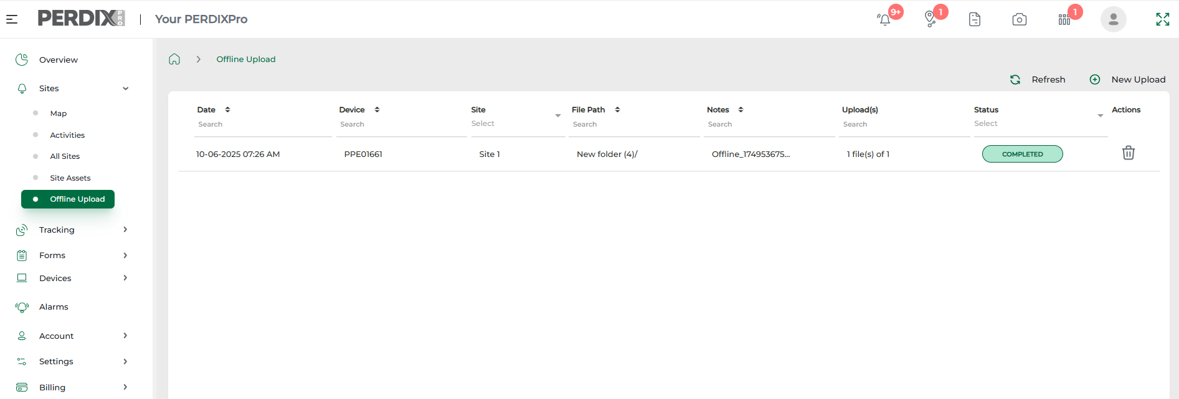
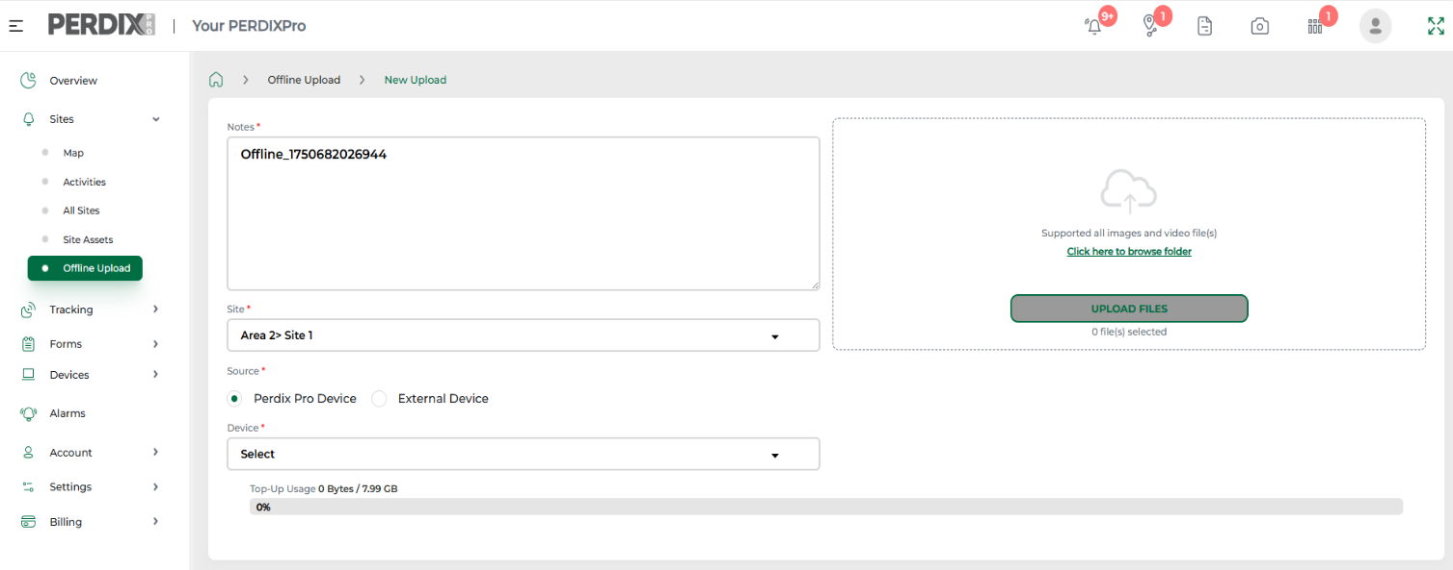
Offline Upload
Click to browse your folder and then once selected, upload files.
When the upload is complete, the folder will show within the Offline Upload menu, and images will appear in Sites > Activities. If you have AI animal recognition feature enabled and subscribed to on the platform, uploaded images will be processed by our AI model.
To upload images
To upload images via the platform, ensure your SD card or images are in a suitable folder on your computer. Navigate to Sites > Offline Upload > New Upload.
Then from the drop down menu, select a Site to associate the images to, and choose the device the images are from. If it is an external device, this will require a device name and model to be added.

Offline upload can be utilised to manually upload images from any trail camera SD card, to the PERDIXPro platform.
This enables image data to be held centrally and images uploaded to be geo-referenced against a Site.
This feature requires a subscription, which can be purchased via Account > Add Ons > Offline Upload (see Add-Ons).
December 2025

