

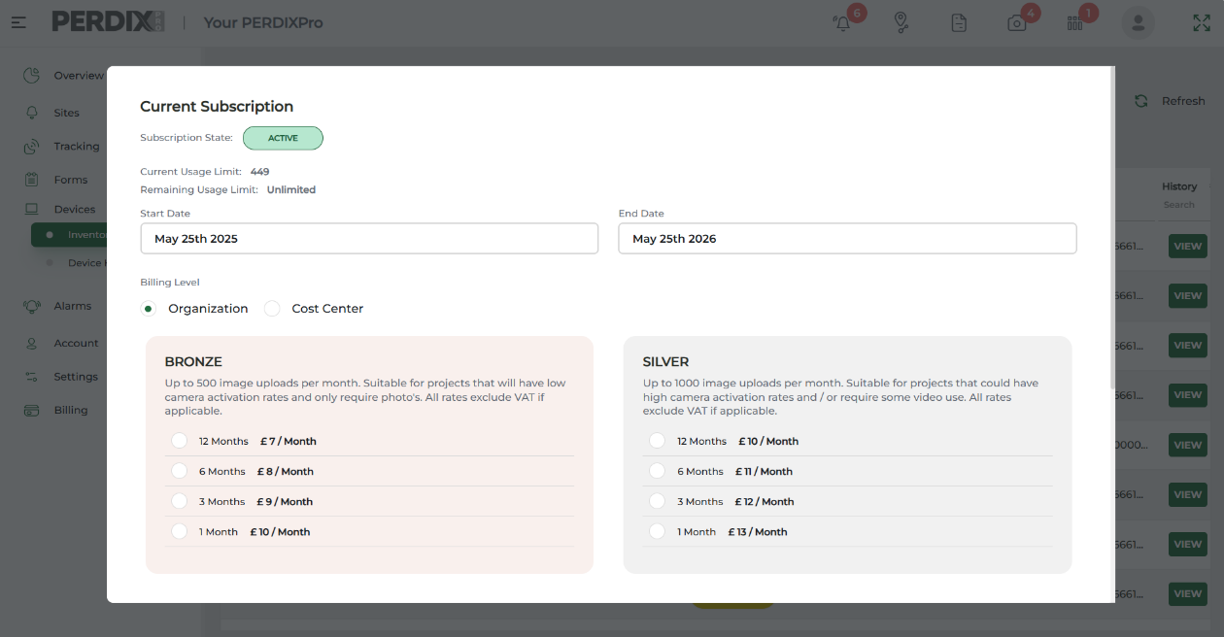
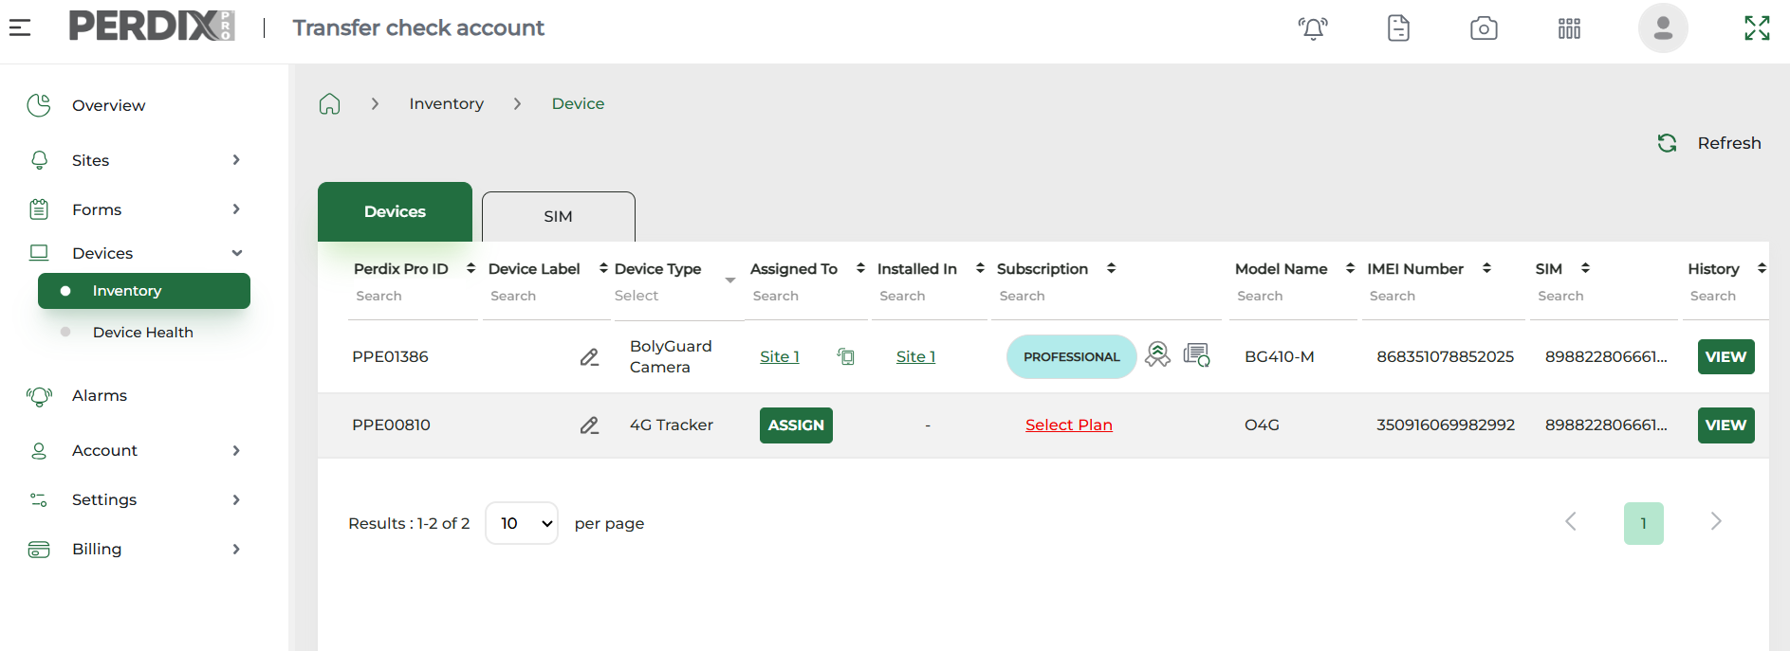
Selecting and Managing Subscriptions
Device subscriptions
Subscriptions for our various devices differ due to the nature of the devices and their purpose. For example, our trap tags provide one level of subscription relating only to period of use. However, our camera subscriptions provide a range of levels of subscriptions offering different image credit amounts, as well as periods of use.
When choosing a subscription to suit your project, you can also apply the cost to the organisation account, or to a pre-prepared costs centre - see Adding Cost Centres. This allows costs relating to the account’s devices within the Device Inventory to be separated for invoicing and budgeting needs.

Selecting a subscription
Device subscriptions are selected within your Device Inventory, against each individual device. To select a plan against a new device in your inventory, click select plan and you will be presented with subscription options.
Once you have assigned the device and selected a subscription plan, the device will become available to install on a Site.




Managing subscriptions
Subscriptions run for selected the time periods, i.e. 1 month, 3 months, 6 months, 12 months. The platform allows you to manage your subscriptions to ensure uninterrupted monitoring, by utilising the following features with your Device Inventory:
Add Top Up Plan
For example, if a camera has a Silver subscription for 3 months, that will allocate 1000 image credits to that camera per month. If the camera exceeds the 1000 credit image allowance for a month, it will stop sending images until the 1000 image upload allocation refreshes the following month. In this scenario, if a camera runs out of image credits within a month, further image credits can be purchased by adding a Top Up Plan.
To check the number of image credits remaining within a month, navigate to your Device Inventory and click the subscription label (i.e. Bronze, Silver, Gold) and the subscription window that appears will show you how long is left on the subscription, as well as the remaining image credits for the current month.
Upgrade Plan
Cameras provide 3 levels of subscriptions of Bronze, Silver and Gold, offering different allocations of image credits. If, during your project, you feel you will require more image credits per month, you can upgrade your subscription plan.
Extend Plan
The platform allows for subscriptions to be pre-planned to suit your project needs. Click Extend plan to select a new plan before the current plan has expired.

Related alarms (see Alarms and Notifications)
Alarms are available to set on the platform to notify of various device and system activities, including subscription expiry and camera allowance usage limits. Device and system alarms can be enabled by navigating to Alarms under the relevant tab.
Camera Allowance Usage Limit
Navigate to Settings > Alarm Settings and select which User Roles can receive these alerts. In More Settings state the % threshold for an alert to be triggered. Under Actions, you can create your own SMS or email messages templates.

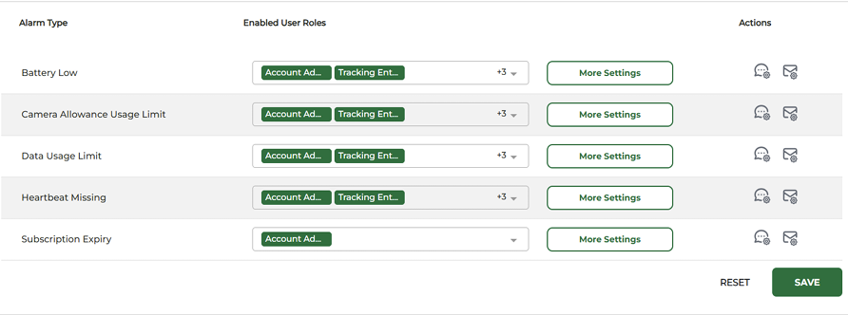

Subscription Alarm
Navigate to Settings > Alarm Settings and select which User Roles can receive these alerts. In More Settings state the subscription expire threshold (in days) for an alert to be triggered. Under Actions, you can create your own SMS or email messages templates.
For individual Users with the chosen User Roles who need to receive these alerts, will need to switch on these alerts within their own access to the account, by navigating to Alarms > SMS & Email Configuration and choosing to receive the alerts by SMS or email (SMS requires SMS credits to be purchased via Account > Add Ons, and email is free).

December 2025

