

Device Activation and Management
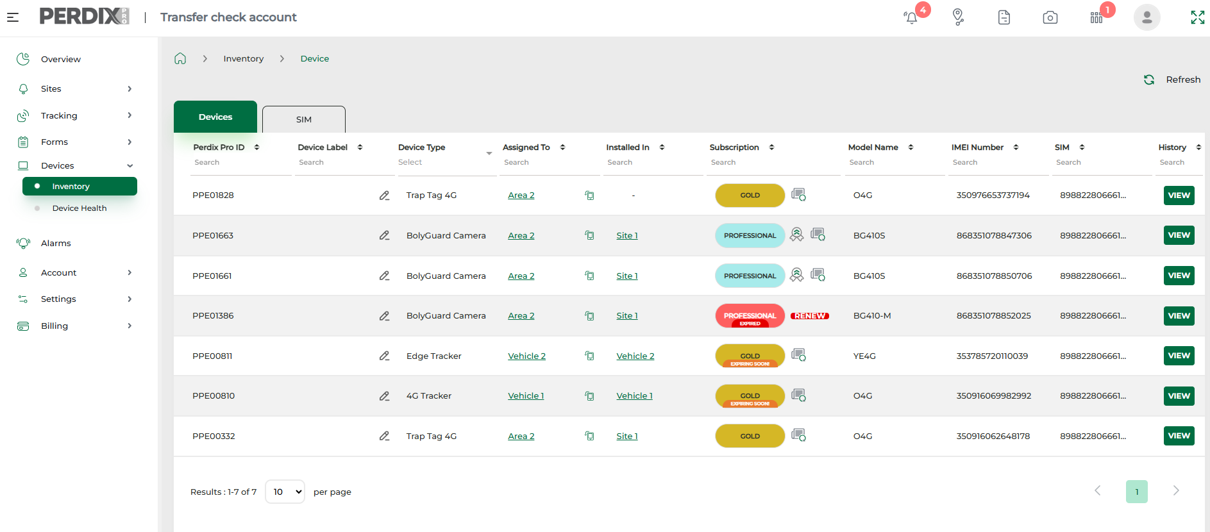
To assign your device
This feature has been included on the platform to allow accounts with large device inventories to manage their devices more effectively, by assigning their devices to various Projects/Departments/Areas/Regions etc.
N.B. Assigning of devices can only be done via the PERDIXPro platform and not the PERDIXPro App. It is beneficial to assign all your devices to the correct section of your account structure prior to devices being deployed in the field.
To assign a new device, go to Devices > Inventory and click the ASSIGN button against your chosen device, then select the section of your account structure to assign the device to. You can re-assign an existing device if that device is not installed on a Site (if it is installed on a Site, you can uninstall, re-assign and re-install).

If you have purchased devices, either PERDIXPro enabled trail cameras, trap tags, or GPS trackers, these devices will be entered into your Device Inventory in your PERDIXPro account and sent to you.
The Device Inventory lists the devices held on the account ready for use (see below), and it is here where you assign your device(s) to an area of your account structure, select and manage subscriptions for each device and view which Site each device is installed on.
N.B. A device MUST be assigned to section of your account structure, have a subscription plan and be installed on a Site for it to be activated.

Selecting a subscription
Device subscriptions are selected within your Device Inventory, against each individual device. To select a plan against a new device, click select plan in your inventory and you will be presented with subscription options of subscription time periods (and activation rates if using cameras).
Once you have assigned the device and selected a subscription plan, the device will become available to install on a Site. For more information see Selecting and Managing Subscriptions.

It is important to note that if you assign your device to a higher level of the account structure, such as a Department level node, that device can be installed and uninstalled freely across the Site nodes attached to that Department, without needing to re-assign.
However, if you directly assign a device to one of the Site nodes linked to the Department, to move it to another Site, you will need to 1) uninstall the device from the Site 2) re-assign it, and then 3) install it on the Site that you require.
N.B. It is beneficial to assign devices to a high level of the account structure, i.e. a Project/Department/Region node, so that the devices can be installed and uninstalled freely across the connected Sites.

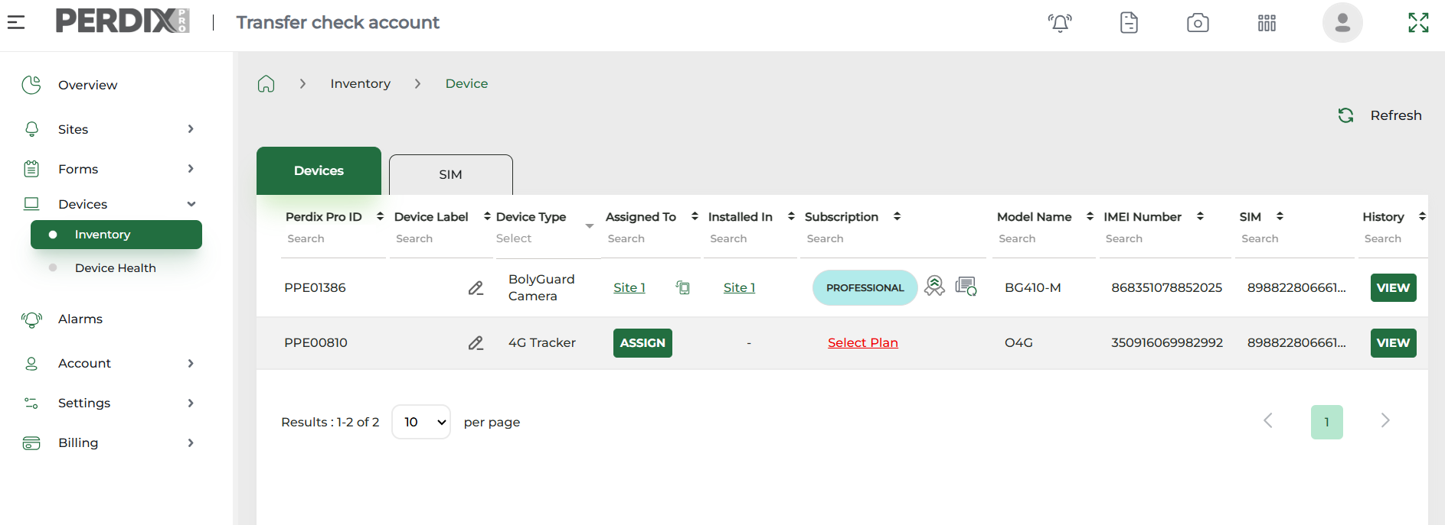
Installing a device
N.B. A device can ONLY be installed on a Site node you have created, or a Structure node which you have ticked as a ‘managed Site’ when it has been created.
To install a device on a Site, follow one of the following steps:
Platform
- Navigate to Sites > All Sites and select the site you wish to install your device.
- Account > Structure and click on the green Site node you wish to install the device, and click View Detail.
PERDIXPro App
- Go to Sites > chosen Site > Devices > Install Device

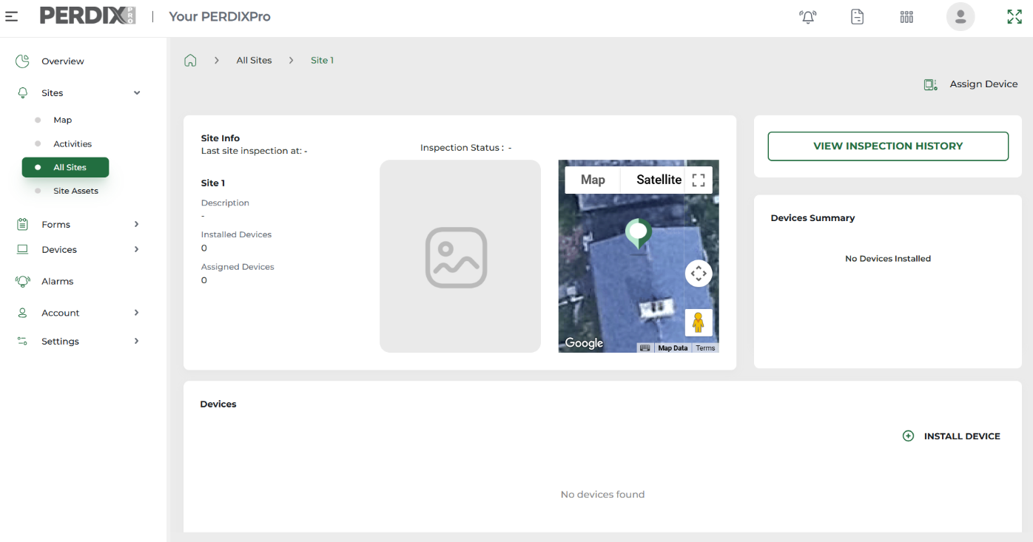
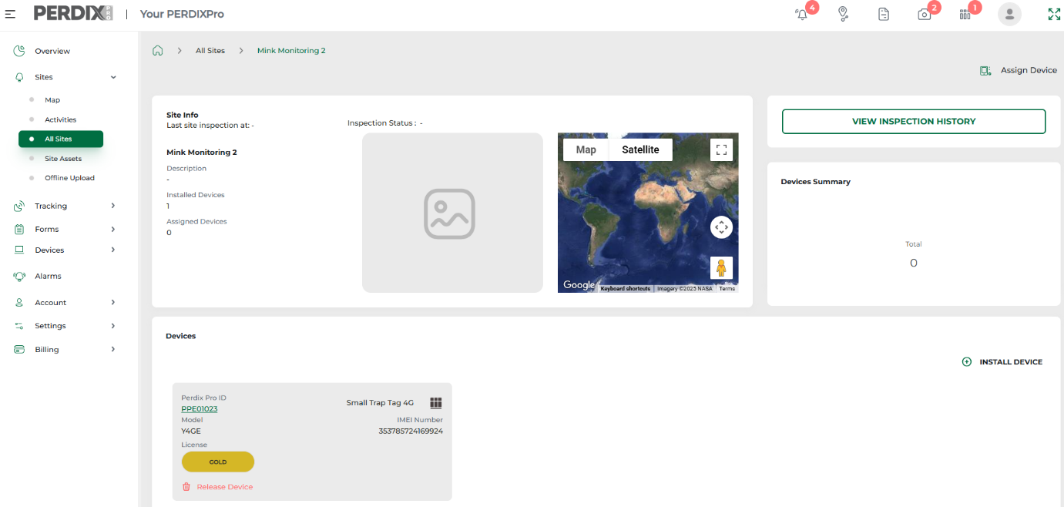
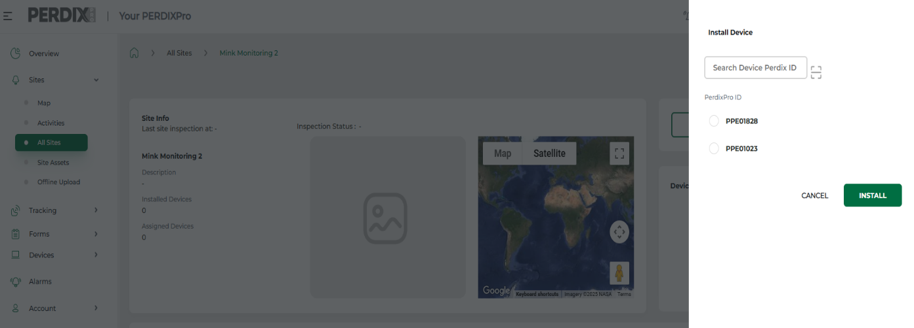
Installed devices can then be released and re-installed on different sites as required.

Both platform avenues will take you to your chosen Site dashboard (see image below), click Install Device and all the devices you have assigned AND selected a subscription for will be listed. Select the device you wish to install, enter battery type and click Install.

Device health
The health of your device can be viewed to understand battery levels, data usage and signal strength. There are two ways to monitor device health:
- Navigate to Devices > Device Health, and here you will see a device health box relating to each of the devices within your Device Inventory. Individual devices can be searched for in the search box by entering the device PPE number.
- Navigate to Sites > All Sites > your chosen Site > your chosen installed device.
N.B Device health data is only updated when data is received from the device, i.e. when an image or a trap tag alert is received.

December 2025

