

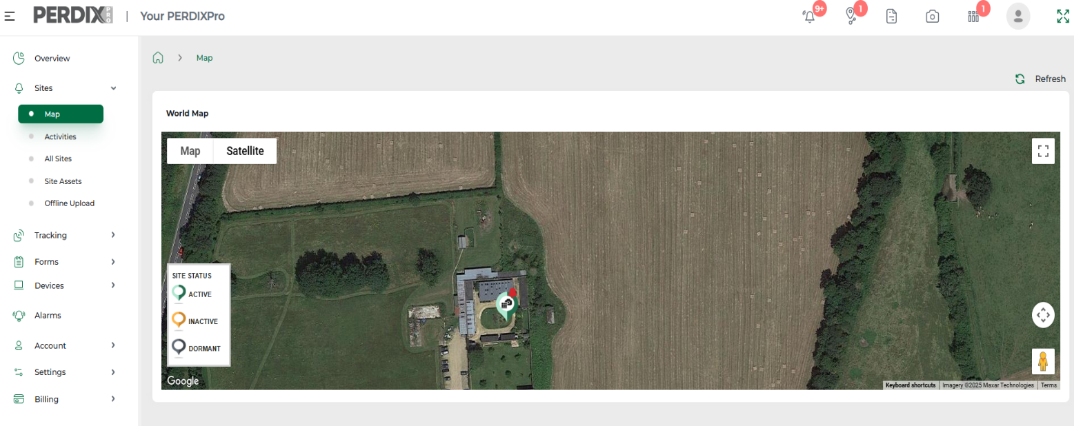
Map and Activities
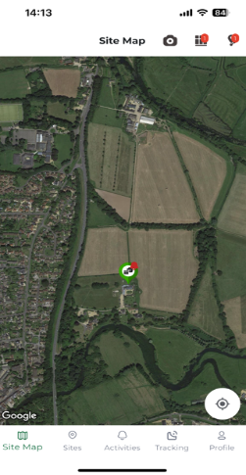

Map
On the platform, the map of your devices can be found via Sites > Map. It visually shows with a pin where your Sites are located. If you have devices installed on those Sites, there will be a cage/camera logo within the Site’s pin.
The status of a Site can be changed from Active, Inactive or Dormant, to visually represent if a Site is being used or not. These categories have no connection to the workings of the devices themselves.
If you are using trap tags and can see them on your Sites across your map, you will also see a little red bell moving on the Site when a trap tag has been activated.
The same map can be viewed via the PERDIXPro App.
The PERDIXPro platform and PERDIXPro App both allow you to view your Sites and their installed devices visually on a map, as well as view all your activities from your devices, including images and trap alerts.

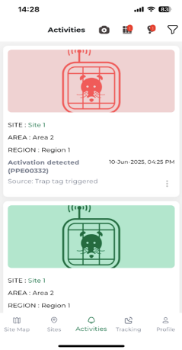
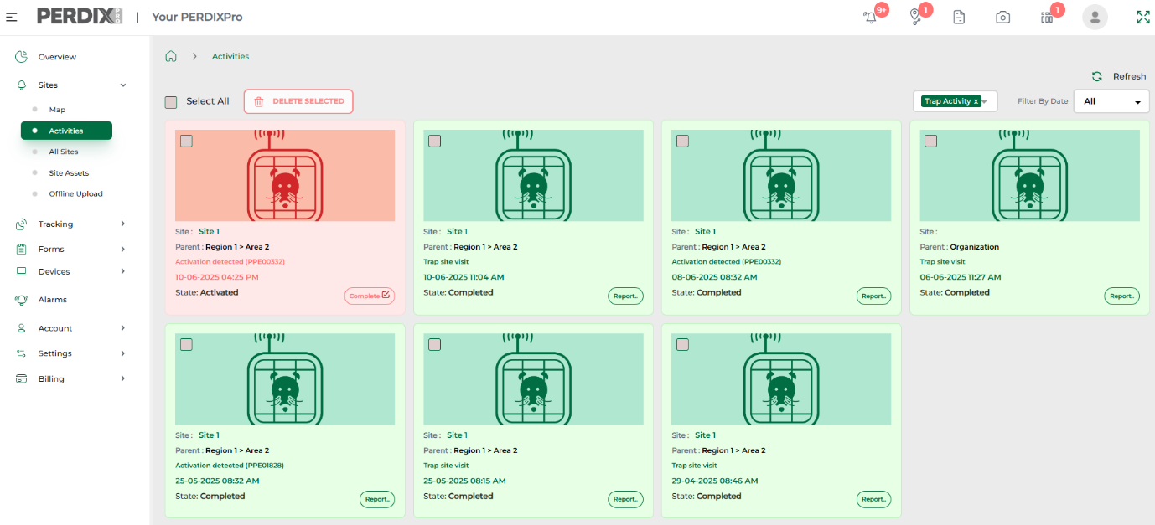
Activities
Your activities, such as images and trap tag alarms received to the platform, can be viewed via the platform Overview page, but in more detail within in Activities. This can be found within the Sites menu.
In Activities, you can filter your activities by activity type and time period, as well as delete activities if required
Below has been filtered by all Trap Activity.
Activities can also be viewed in the same way via the PERDIXPro App.

December 2025

