

Adding Cost Centres
The PERDIXPro platform provides functionality to add cost centres. This is a useful feature if an account has a large number of devices in their device inventory, and usage costs against those devices and other platform subscriptions need to be applied to specific departments or projects.
Adding a cost centre
Navigate to Billing > Cost Centre > Add Cost Centre

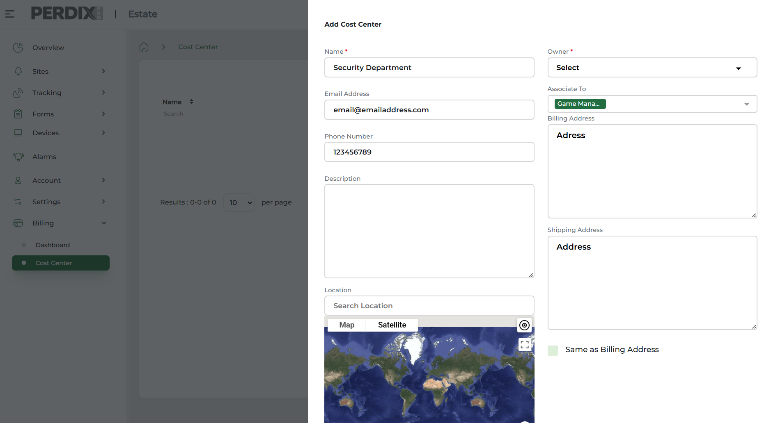

Complete the details required and save.
Once cost centres are created, they will then be available to select across the various subscription packages on the platform.
For example, when selecting a subscription plan for a device, you will have the option to apply the cost to the account (i.e. Organisation) or to a cost centre through a drop down selection.

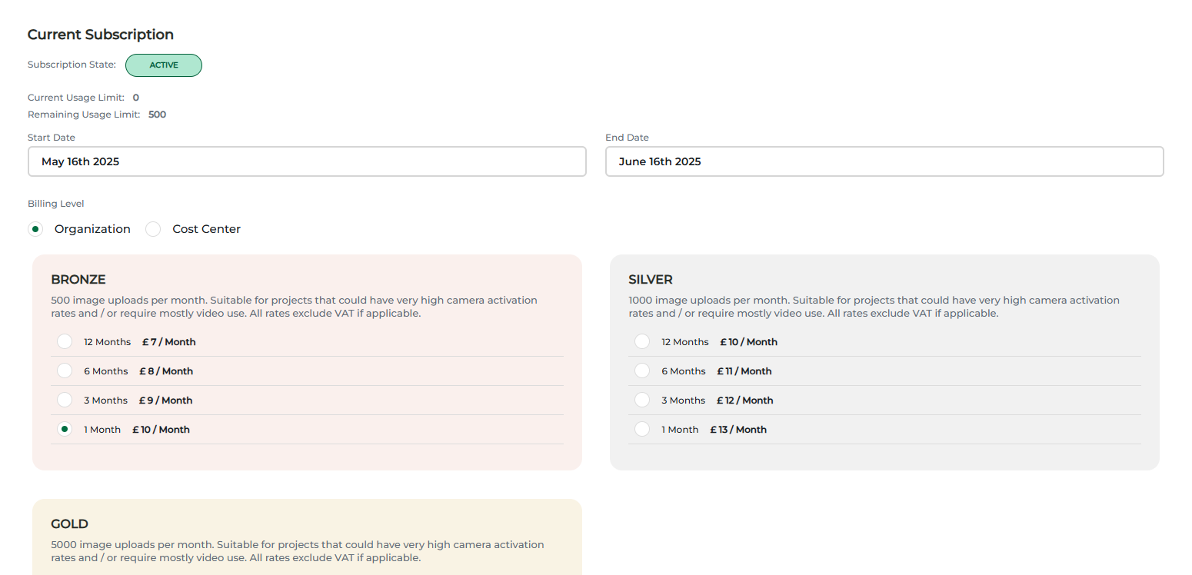
The cost centre name will be added to the invoice when generated.
Invoices are generated on the 1st of the following month of when a cost is incurred. A red alert will show at the top of your account on the bill icon, to notify you of an outstanding invoice(s).

December 2025

