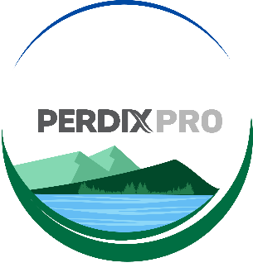

Setting up your account structure
The set up of your account’s structure is an important aspect of the management of your PERDIXPro account.

It is a bespoke digital representation of your project/estate/reserve/organisation etc. Correct set up will allow you to manage your PERDIXPro activities more efficiently and effectively, as well as allow for the correct access to be given to registered users invited onto the account.

Your PERDIXPro account structure is created using digital nodes representing your Projects/Departments/Areas/Sites etc, and these digital nodes are where devices within your account’s Device Inventory, and forms within My Forms, can be assigned for use.

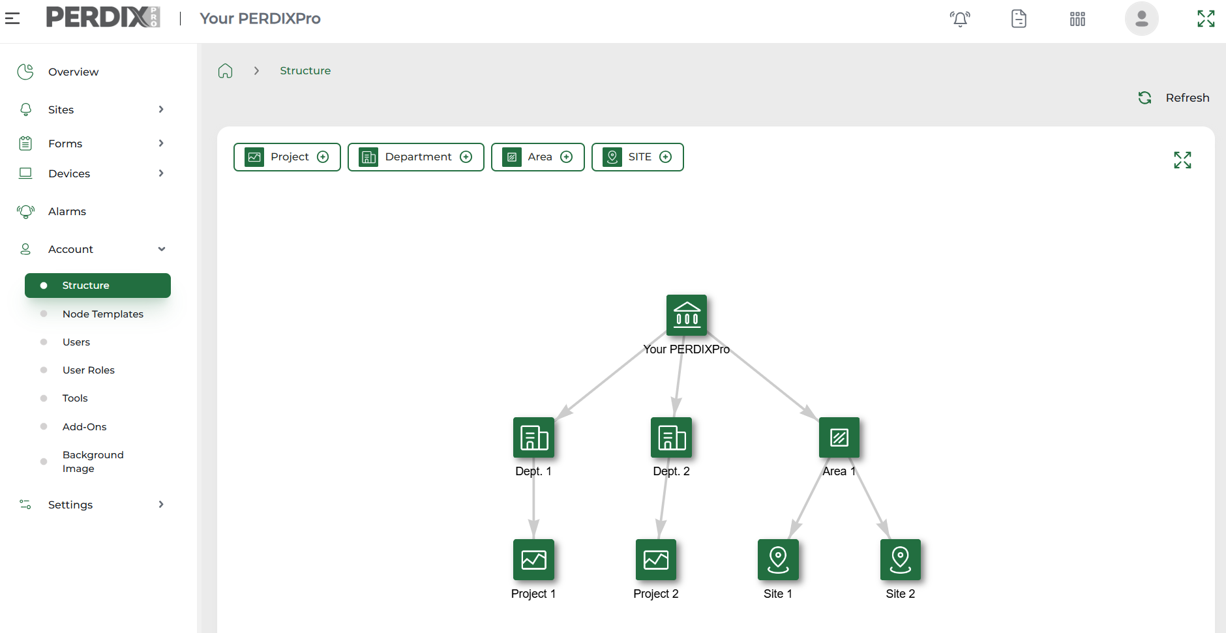

To create your own digital nodes, navigate to Account > Node Templates > Add Node Template. Provide the node template with a name, a description (if applicable) and add an icon. Tick the box if the node will be a ‘managed Site’ and you will be installing devices on this node.
N.B Devices can ONLY be installed on a Site node, or a node that has been ticked as a ‘managed Site’. Digital forms can be associated with any node.

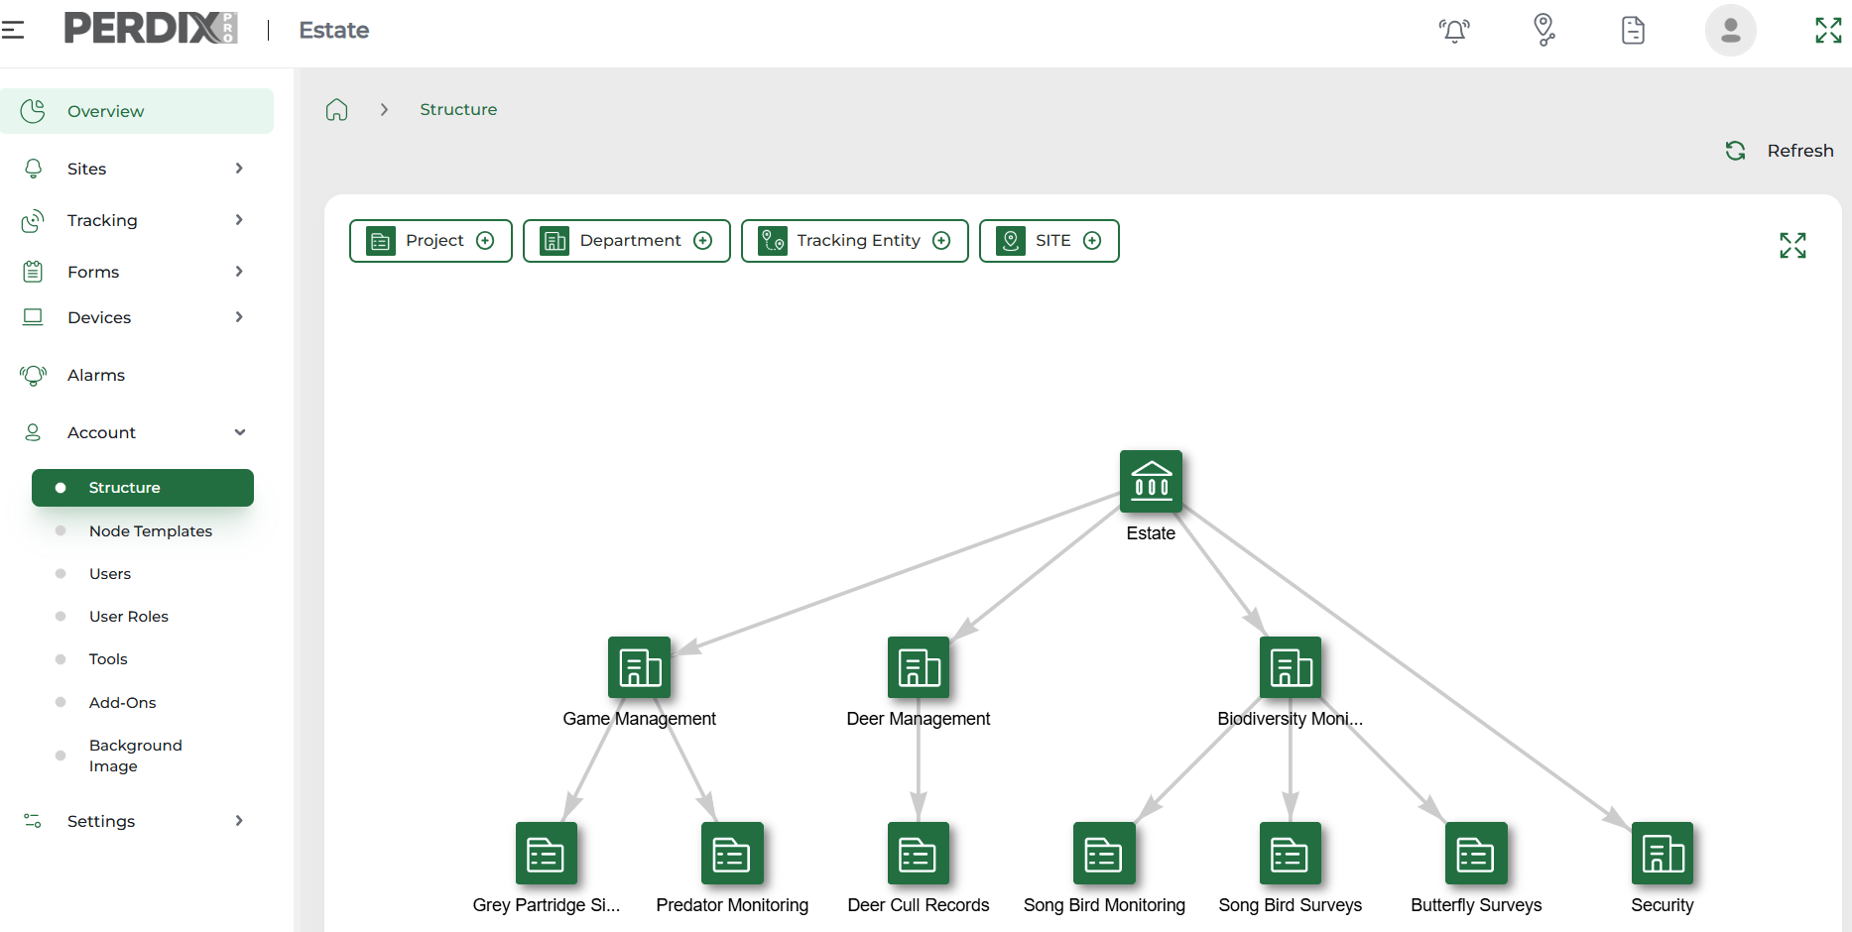
Example account structure set up - Estate

An Estate is using PERDIXPro enabled trail cameras to monitor predators, deer presence, song bird use on their farmland birds feeders, grey partridge sightings, and also for security purposes.

They are also using the PERDIXPro digital form builder to collect data on butterfly numbers in their managed woodland rides, to conduct farmland bird surveys, record predator management activities, and they have recently created a form to record deer cull numbers across their contracted stalkers.
Structures can of course be built over time, added to and edited, but for this example, we will create a comprehensive PERDIXPro account structure to support the estate’s current wildlife management and monitoring needs. They will therefore need various department and project nodes.
We will start to build the account structure hierarchy at Department level, and first add a node template called ‘Department’.

Once this node is added you will see it appear at the top of your Account Structure, to be available to add various departments (See below). Then we can add a Project node, and continue to build the structure.

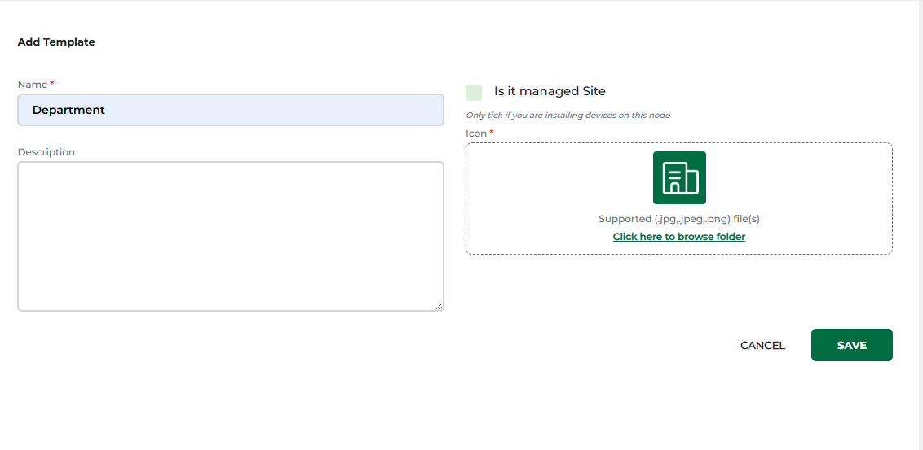
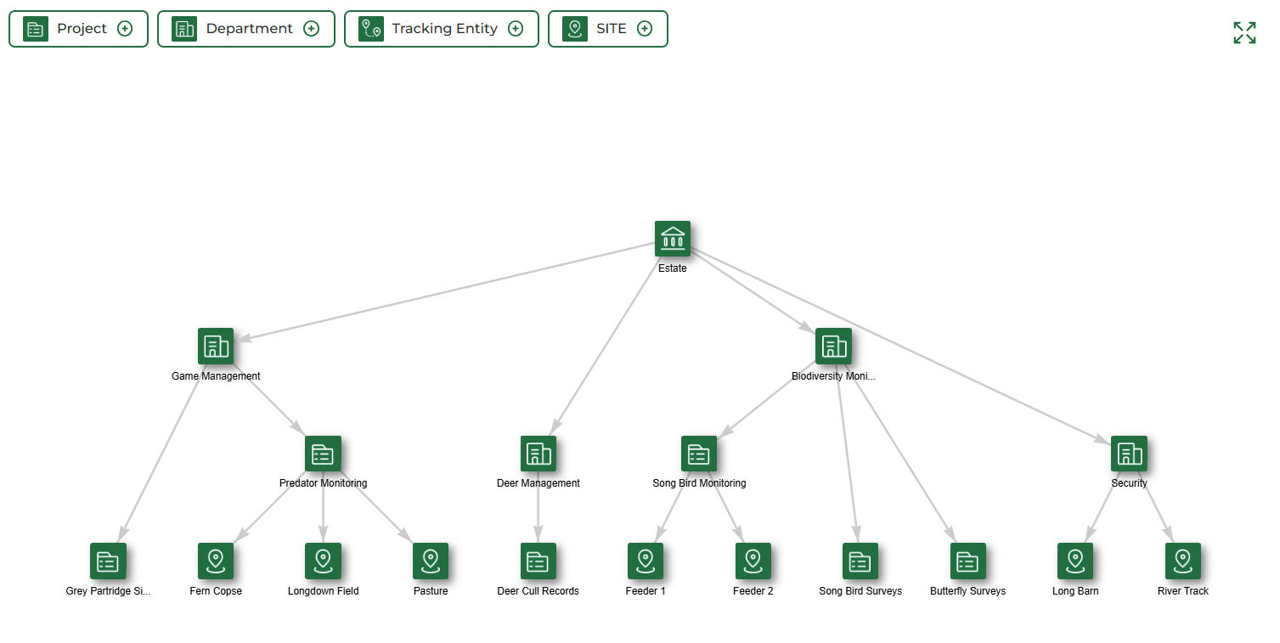

The structure is now ready for devices to be installed on Sites, forms to be associated throughout the hierarchy where required, and for users to be given access to areas relevant to them.

Next, we need to add Sites to the Project nodes that require devices for monitoring, as devices can only be installed on Site nodes or nodes that have been ticked as a ‘managed Site’.

December 2025

