

Enabling Digital Tools to use your devices
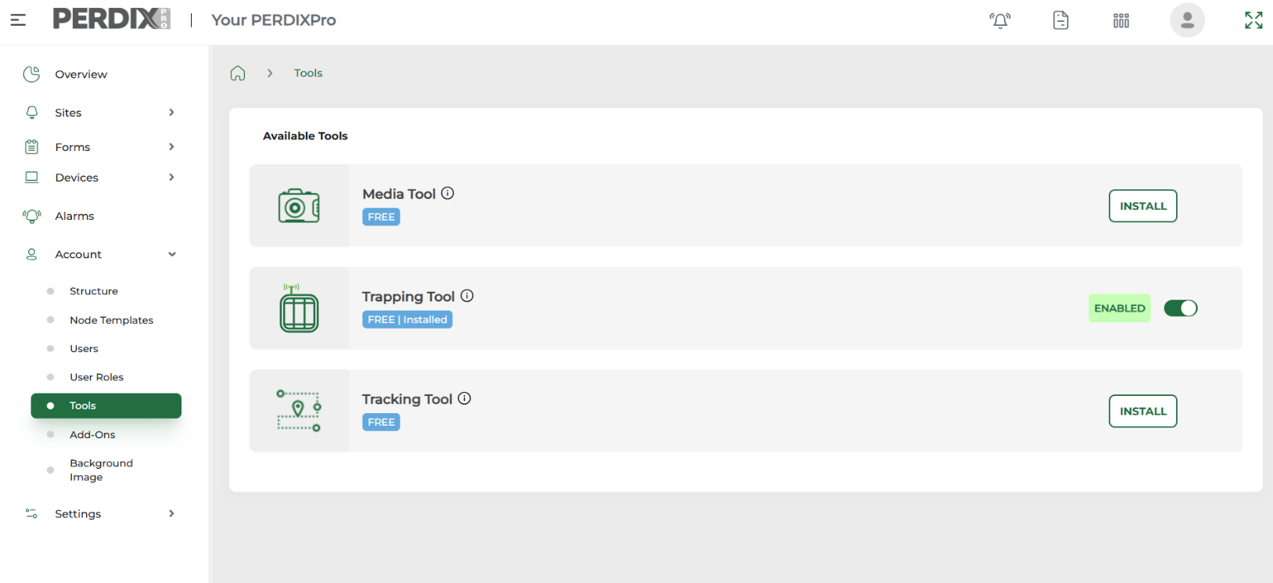
If you have purchased PERDIXPro enabled trail cameras, you will need to enable the Media Tool.
If you have purchased PERDIXPro GPS Tracking Tags, you will need to enable the Tracking Tool.

Once your chosen Tool is enabled, you will then be able to see the various features related to your specific Tool, appear across the PERDIXPro menu.

When you log into your account for the first time, you will be presented with the main Dashboard, but first you will need to enable the PERDIXPro Tool you require.
For example, if you have purchased a PERDIXPro trap tag, you will need to install the Trapping Tool to be able to use it. To do this, go to the menu on the left side of the screen, click on Account > Tools and enable the Trapping Tool. You will now see Devices appear in the menu list and your purchased tags listed within your Device Inventory.

Media Tool Features
When you enable the Media Tool, this will give you access to the menu option called Devices. In here you will be able to see your camera devices listed within your Device Inventory and once connected, the health of your devices within Device Health.
Our system provides facility to receive images/videos remotely from PERDIXPro enabled trail cameras. When the Media Tool is enabled you will also be given access to Offline Upload via Sites > Offline Upload, where images/videos from any trail camera SD card can be uploaded to the platform (please note the Offline Upload requires a bought subscription via Account > Add Ons, which will also become available when this Tool is enabled).
In Settings, you will also gain access to General Settings where you can adjust the New Media Indicator Interval, Site Inspection Interval and Activity Deletion Interval.
Please see our Media_Quick_Start Guide for more information on how to set your trail cameras up on our PERDIXPro platform and App.
Tracking Tool Features
When you enable the Tracking Tool, this will give you access to the menu option called Devices. In here you will be able to see your tracking devices listed within your Device Inventory and when connected, the health of your devices within Device Health.
This Tool will give you access to the menu option called Tracking. In the drop down you will be able to see your tracking Dashboard, Tracking Entities (when created), as well as your Geofence Alerts and Geofences.
Please see our Tracking_Quick_Start Guide for more information on how to set up your tracking tags on our PERDIXPro platform and App – coming soon
December 2025
Trapping Tool Features
When you enable the Trapping Tool, this will give you access to the menu option called Devices. In here you will be able to see your trap tag devices listed within your Device Inventory and when connected, the health of your devices within Device Health.
Our trap tags also allow you to collect data of your trapping activities via a Trap Activity Form, which can be submitted when completing a trapping alert. The contents of this form can be set up to reflect different trap types/bait types/target species, and this feature will also become available in Forms > Trapping Forms Setup, when the Trapping Tool is enabled.
In Settings, you will also gain access to General Settings where Site inspection Intervals can be adjusted.
Please see our Trapping_Quick_Start Guide for more information on how to set up your trap tags on our PERDIXPro platform and App.

